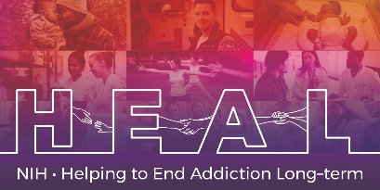

The Columbia-Suicide Severity Raring Scale (C-SSRS) is Copyrighted.
To access this measure, please contact the developers https://cssrs.columbia.edu/the-columbia-scale-c-ssrs/cssrs-for-research/ to obtain a license for this measure.

When applying for access, please indicate that you are conducting research as part of the NIH HEAL Initiative:

“Our study is a NIH funded study. We are part of the HEAL Initiative.”

Once you have license permission, please share your email confirmation with HEAL_CDE@hsc.utah.edu for access to the NIH HEAL Initiative’s CDE for this measure.

English CRF is available.

