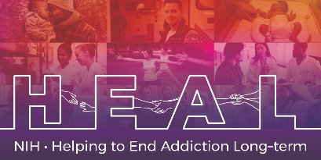

The Connor-Davidson Resilience Scale (CD-RISC) 2 is Copyrighted.
To access this measure, please obtain a license from: http://www.connordavidson-resiliencescale.com/contact.php
When applying for access, please indicate that you are conducting research as part of the NIH HEAL Initiative:

“Our study is a NIH funded study. We are part of the HEAL Initiative.”

Once you have license permission, please share your email confirmation with HEAL_CDE@hsc.utah.edu for access to the NIH HEAL Initiative’s CDE for this measure.

English CRF is available.

