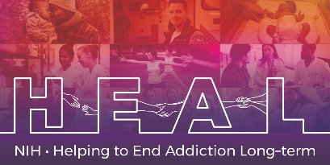

The RAVLT is Copyrighted.
To access this measure, please contact Mapi Research Trust: https://eprovide.mapi-trust.org/instruments/rey-auditory-verbal-learning-test

When applying for access on Mapi Research Trust, please indicate that you are conducting research as part of the NIH HEAL Initiative:

“Our study is a NIH funded study. We are part of the HEAL Initiative.”

Once you have license permission, please share your email confirmation with HEAL_CDE@hsc.utah.edu for access to the NIH HEAL Initiative’s CDE for this measure.

English CRF is available.

